AIM
To write a Python program using NumPy to access and display specific elements, rows, columns, and sub-matrices of a 2D array.

ALGORITHM
- Start the program.
- Import the NumPy library using import numpy as np.
- Create a 3×33×3 matrix containing the elements 10 to 90.
- Display the entire matrix.
- Access and display the element at index [1, 2].
- Access and display the first row using matrix[0, :].
- Access and display the second column using matrix[:, 1].
- Extract and display the top-left 2×22×2 sub-matrix using matrix[0:2, 0:2].
- Stop the program.

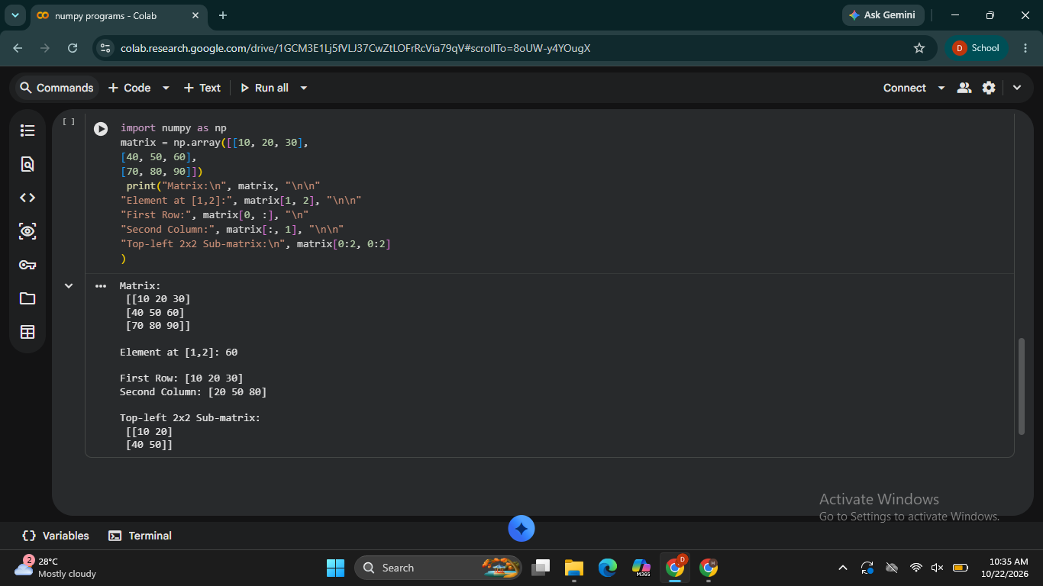

RESULT
Thus, the Python program using NumPy was executed to access and display a specific element, the first row, the second column, and the top-left 2×22×2 sub-matrix of a 2D array.

